**Online Examination System**

**Introduction**

The Online Examination System is a Java-based desktop application designed to make taking exams over the internet easy and convenient.

This project aims to provide a user-friendly platform for creating, managing, and conducting exams online. With features like user authentication, exam creation, and result processing, the system simplifies the exam process for educational institutions and organizations.

Using Java's Swing library, the application offers a simple and intuitive interface for users to navigate through exams. With clear instructions and interactive elements, taking exams becomes straightforward for everyone involved, the Online Examination System provides a hassle-free solution for administering exams online. Its ease of use and functionality make it a valuable tool for modern education and assessment practices.

**Features**

* Loading Screen: Presents a loading screen upon launching the application.
* Sign-up Page: Allows users to create new accounts, validating input data to ensure correctness.
* Sign-in Page: Provides a sign-in interface for existing users, displaying previous exam results if available.
* Exam Taking: Guides users through the exam process, preventing retakes for completed exams.
* Results Display: Shows exam results upon submission, redirecting users to the login screen afterward.

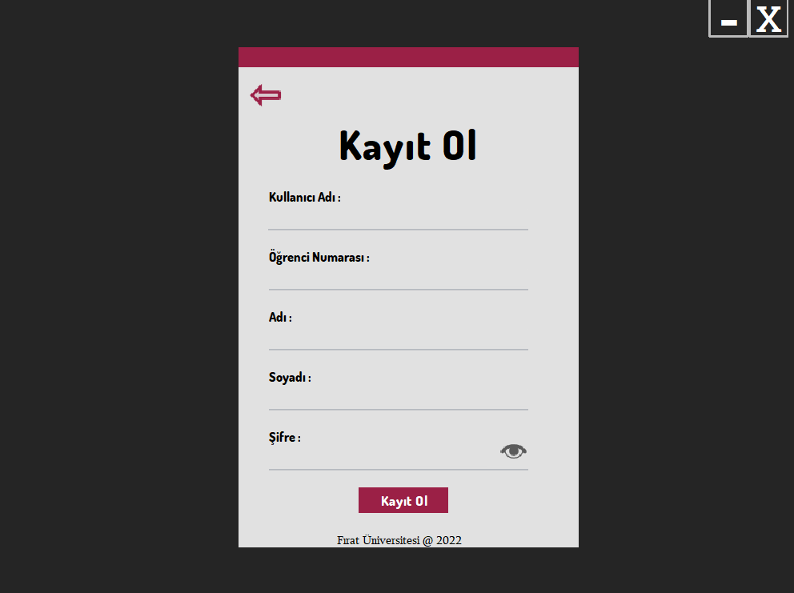

UI :





**Conclusion**

* Achievements

The Online Examination System successfully provides a user-friendly platform for online exams, featuring essential functionalities like user authentication and result processing.

* Lessons Learned

Key lessons include the importance of intuitive UI design, robust data validation, and thorough testing for project success.

* Next Steps

Future developments may focus on scalability, security enhancements, and advanced analytics to meet evolving user needs and improve system capabilities. Ongoing user feedback will guide iterative improvements.

**Credits**

This project is maintained by @malikmaky.

For any inquiries or feedback, please contact malikmhmd@hotmail.com